 | 18.3 Editors - Graph Editor - Sidebar
Table of content
Introduction 1
Right Click menus 1

Introduction

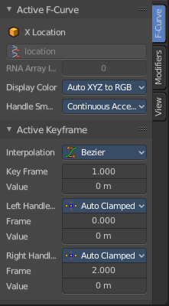
The Movie Clip Editor is made of several areas. And it is made of several modes with different editor types.
At the right side you will find the sidebar in Tracking Mode with Clip view. And in Masking mode. In the sidebar you will find further options and settings for the Movie Clip Editor and its tools.

Right Click menus

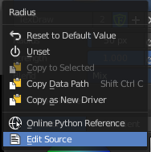
You will open the usual right click menus when clicking with the right mouse at elements in the sidebar. Its content is in big parts self explaining.
The right click menus are explained in the chapter 6 Editors Introduction.

